* **Name of the Activity:** A Web Talk on "Hal Cherona Bondhu (Do not give up friends)"
* **Type of the Activity:** Web-Talk
* **Organizing Department:** Women's Cell, Chakdaha College
* **Date and time of the Activity:** 25.12.2020 from 18.30 pm – 21.30 pm
* **Speakers**: Dr. Nandini Bhowmick, Professor, Eminent Theatre Artist and Priest
* **Link of the Programme:** <https://youtu.be/O3-Wdf72qZM>
* **Number of Views:** 242
* **Outcome:** 
  + Students learned to remain positive and maintain a never-give-up attitude to reach their goals in life.
  + Students learned that no job is small, but the dignity of labour is important.
  + Students learned it is important to cultivate positive energy and not take it for granted to achieve success.
* **Flyer:**

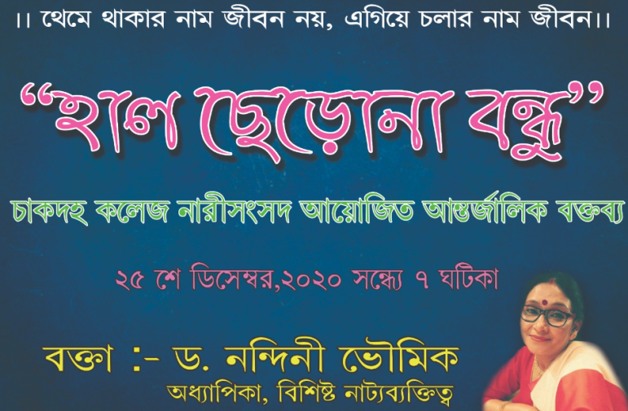

* **Photograph of the Programme:**

